Department of Computer Science and Engineering
DSA0101 – Object Oriented Programming with C++
Individual Contribution Statement
Project: Smart Civic Complaint and Public Safety Response System using C++
POOJA S - 192524211
Primary Responsibility: Application Integration & Core System Implementation – Menu-driven system, response-team management, priority handling, and report generation
Detailed Contribution:
- Designed and implemented the overall menu-driven structure of the Smart Civic Complaint and Public Safety Response System.
- Developed and integrated the complaint management workflow, including complaint registration, classification, priority evaluation, team assignment, and status updates.
- Implemented the ResponseTeam abstract base class and integrated derived municipal teams such as Sanitation, Road Maintenance, Electrical, Water Supply, and Public Safety teams.
- Implemented runtime polymorphism using base-class pointers and virtual functions to dynamically handle different municipal response teams.
- Developed team workload and capacity tracking functionality and implemented operator overloading for comparing team workloads and combining workload/capacity values.
- Implemented the civic response report generation module, displaying total citizens, total complaints, active complaints, complaint priorities, statuses, and response-team workloads.
- Integrated the different modules and performed functional testing to ensure proper interaction between citizens, complaints, and response teams.
- Contributed to debugging, error correction, and final testing of the complete Smart Civic Complaint and Public Safety Response System application.

- Pseudo code
START

DECLARE maximum citizens = 50
DECLARE maximum complaints = 100

CREATE Citizen class
PRIVATE:
citizenId
name
phone
address

PUBLIC:
Default Constructor
Parameterized Constructor
Copy Constructor
getId()
getName()
display()
Destructor
END CLASS

CREATE Complaint class
PRIVATE:
complaintId
citizenId
category
description
urgency
priorityScore
status
assignedTeam

STATIC:
totalComplaints
activeComplaints

PUBLIC:
Default Constructor
Parameterized Constructor
Copy Constructor
calculatePriority()
get complaint details
assignTeam()
updateStatus()
overload > operator to compare priority
overload < operator to compare priority
display()
Destructor
END CLASS

CREATE MunicipalResource class
PROTECTED:
resourceId
resourceName

PUBLIC:
Constructor
displayResource()
Virtual Destructor
END CLASS

CREATE ABSTRACT ResponseTeam class
PROTECTED:
teamId
teamName
workload
capacity

STATIC:
availableTeams

PUBLIC:
Default Constructor
Parameterized Constructor

DECLARE PURE VIRTUAL FUNCTION:
respondToComplaint()

DECLARE VIRTUAL FUNCTION:
getSpecialization()

displayTeam()

overload + operator
Destructor
END CLASS

CREATE FieldOperations class
VIRTUALLY INHERIT MunicipalResource
END CLASS

CREATE EmergencyOperations class
VIRTUALLY INHERIT MunicipalResource
END CLASS

CREATE DIFFERENT RESPONSE TEAMS

SanitationTeam inherits ResponseTeam

RoadMaintenanceTeam inherits ResponseTeam

ElectricalTeam inherits ResponseTeam

WaterTeam inherits ResponseTeam

PublicSafetyTeam inherits:
ResponseTeam
FieldOperations
EmergencyOperations

END

CREATE ARRAY citizens[MAX_CITIZENS]
CREATE ARRAY complaints[MAX_COMPLAINTS]

SET citizenCount = 0
SET complaintCount = 0

FUNCTION RegisterCitizen()

IF citizenCount is equal to MAX_CITIZENS
DISPLAY "Citizen storage is full"
RETURN
END IF

INPUT citizen ID
INPUT citizen name
INPUT phone number
INPUT address

CREATE Citizen object

STORE citizen in citizens array

INCREMENT citizenCount

DISPLAY "Citizen Registered Successfully"

END FUNCTION

FUNCTION CitizenExists(citizenId)

FOR every registered citizen

IF citizen ID matches input ID
RETURN TRUE
END IF

END FOR

RETURN FALSE

END FUNCTION

FUNCTION RegisterComplaint()

IF complaintCount is equal to MAX_COMPLAINTS
DISPLAY "Complaint storage is full"
RETURN
END IF

INPUT complaint ID
INPUT citizen ID

IF citizen does not exist
DISPLAY "Register citizen first"
RETURN
END IF

DISPLAY complaint categories

INPUT category choice

ASSIGN category according to choice

INPUT complaint description

INPUT urgency level

CALCULATE priority score

CREATE Complaint object

STORE complaint in complaints array

INCREMENT complaintCount

DISPLAY "Complaint Registered Successfully"

END FUNCTION

FUNCTION CalculatePriority()

ASSIGN category score according to complaint category

priorityScore =
urgency × 10 + categoryScore

RETURN priorityScore

END FUNCTION

FUNCTION DisplayComplaints()

IF no complaints exist
DISPLAY "No complaints registered"
RETURN
END IF

FOR every complaint

DISPLAY complaint details

END FOR

END FUNCTION

FUNCTION FindComplaint(complaintId)

FOR every complaint

IF complaint ID matches
RETURN complaint index
END IF

END FOR

RETURN -1

END FUNCTION

FUNCTION AssignComplaint(ResponseTeam pointers)

INPUT complaint ID

FIND complaint

IF complaint does not exist
DISPLAY "Complaint not found"
RETURN
END IF

GET complaint category

IF category is Garbage
SELECT SanitationTeam

ELSE IF category is Pothole
SELECT RoadMaintenanceTeam

ELSE IF category is Streetlight
SELECT ElectricalTeam

ELSE IF category is Water Leakage
SELECT WaterTeam

ELSE IF category is Unsafe Public Space
SELECT PublicSafetyTeam

ELSE
DISPLAY "No suitable response team available"
RETURN
END IF

CALL respondToComplaint()

ASSIGN selected team to complaint

INCREMENT team workload

END FUNCTION

FUNCTION UpdateComplaintStatus()

INPUT complaint ID

FIND complaint

IF complaint does not exist
DISPLAY "Complaint not found"
RETURN
END IF

DISPLAY status options:
Pending
Assigned
In Progress
Resolved

INPUT new status

UPDATE complaint status

IF complaint becomes Resolved
DECREMENT activeComplaints
END IF

DISPLAY "Status Updated Successfully"

END FUNCTION

FUNCTION CompareComplaints()

INPUT first complaint ID
INPUT second complaint ID

FIND both complaints

IF either complaint does not exist
DISPLAY "Complaint not found"
RETURN
END IF

USE overloaded > operator

IF first complaint priority is greater
DISPLAY first complaint has higher priority

ELSE IF second complaint priority is greater
DISPLAY second complaint has higher priority

ELSE
DISPLAY both complaints have equal priority
END IF

END FUNCTION

FUNCTION DisplayTeamWorkload()

FOR every response team

DISPLAY:
Team ID
Team Name
Specialization
Workload
Capacity

END FOR

USE overloaded + operator

CALCULATE combined workload
of two response teams

DISPLAY combined workload

END FUNCTION

FUNCTION GenerateReport()

SET pending = 0
SET assigned = 0
SET inProgress = 0
SET resolved = 0

FOR every complaint

CHECK complaint status

INCREMENT corresponding status count

END FOR

DISPLAY:
Total Citizens
Total Complaints
Active Complaints
Resolved Complaints
Pending Complaints
Assigned Complaints
In Progress Complaints
Available Response Teams

END FUNCTION

MAIN FUNCTION

CREATE:
SanitationTeam object
RoadMaintenanceTeam object
ElectricalTeam object
WaterTeam object
PublicSafetyTeam object

CREATE array of ResponseTeam pointers

STORE addresses of all teams
in ResponseTeam pointer array

REPEAT

DISPLAY MENU:

1. Register Citizen
2. Display Citizens
3. Register Complaint
4. Display Complaints
5. Assign Complaint to Response Team
6. Update Complaint Status
7. Compare Complaint Priorities
8. Display Team Workload
9. Generate Civic Response Report
0. Exit

INPUT user choice

SWITCH choice

CASE 1:
RegisterCitizen()

CASE 2:
DisplayCitizens()

CASE 3:
RegisterComplaint()

CASE 4:
DisplayComplaints()

CASE 5:
AssignComplaint()

CASE 6:
UpdateComplaintStatus()

CASE 7:
CompareComplaints()

CASE 8:
DisplayTeamWorkload()

CASE 9:
GenerateReport()

CASE 0:
DISPLAY "Thank you for using the system"

DEFAULT:
DISPLAY "Invalid Choice"

END SWITCH

UNTIL user choice is 0

END

- IMPLEMENTATION AND OUTPUT
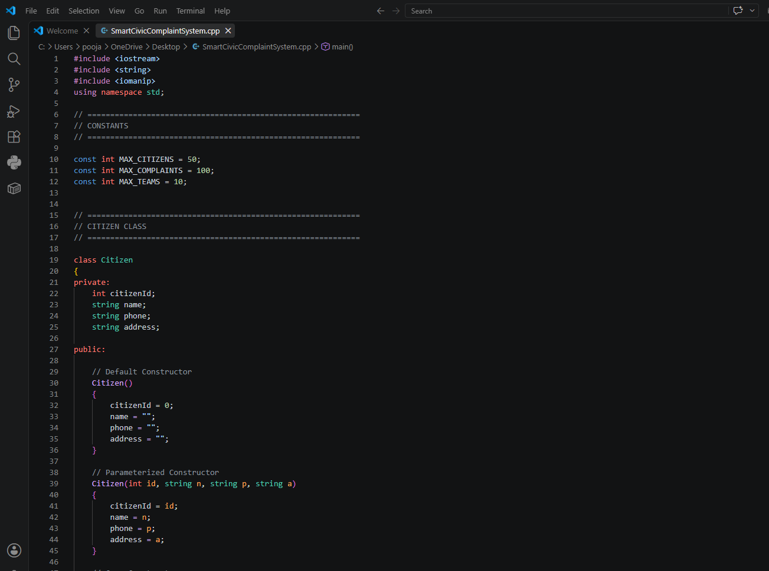
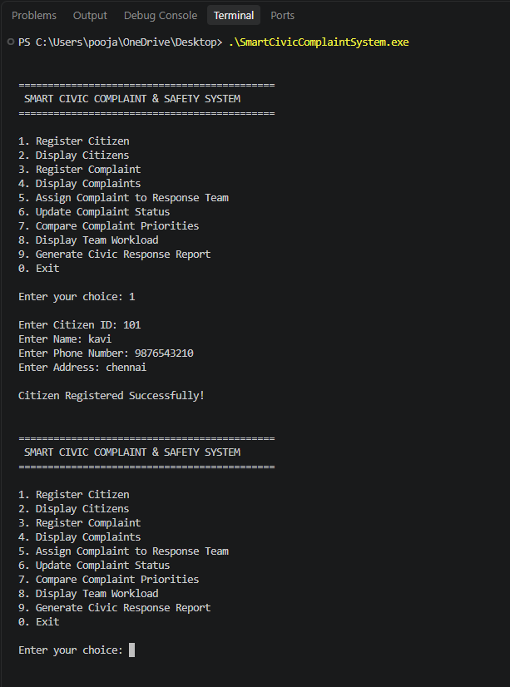

- Github Upload

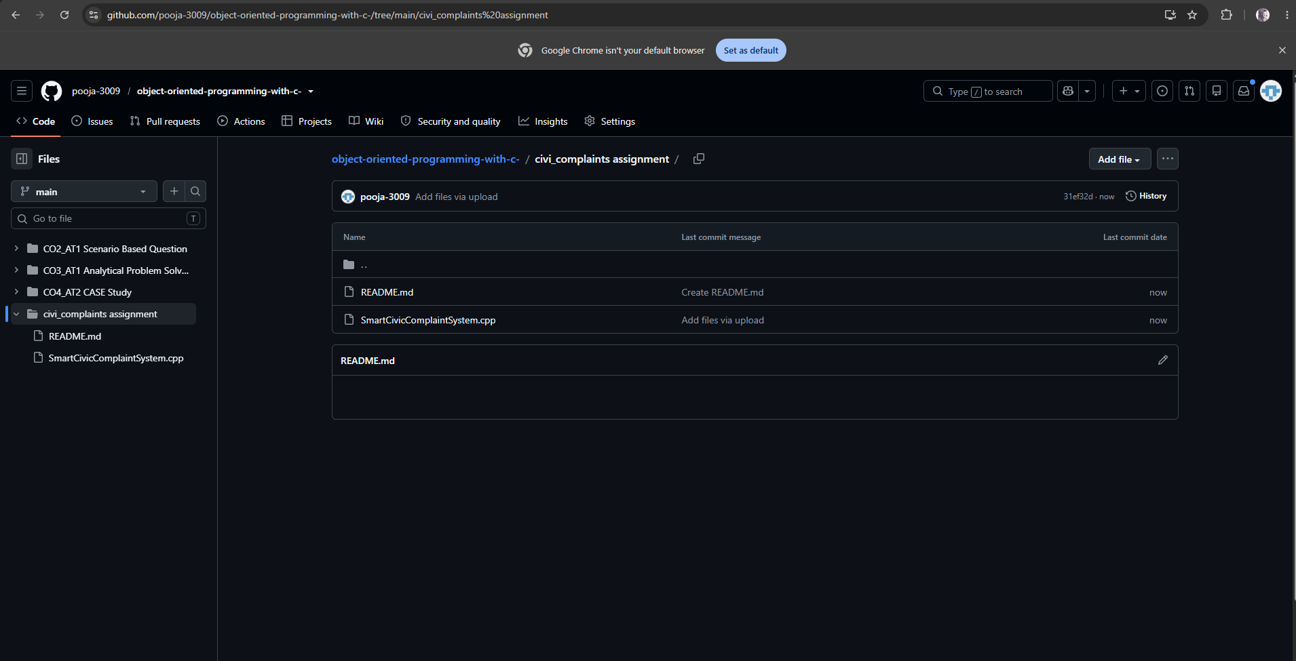
https://github.com/pooja-3009/object-oriented-programming-with-c-/tree/main/civi_complaints%20assignment

DECLARATION:
I confirm that the above accurately reflects my individual contribution to the design, implementation, integration, testing, and documentation of this project.

